**TEXTBOOK WORKSHEET – CHAPTER 1**

**Name ___________________________________ Period ________________________**

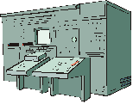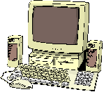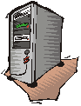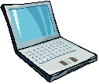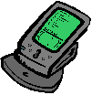

|  |  |
| --- | --- |
| ***Device*** | ***Write a short description for each device. Answers are on Page 15 Table 1-2*** |
|  |  |
| **PC** |  |
| **Mac** |  |
| **Networked** **Computer** |  |
| **Laptop** |  |
| **Palmtop/PDA** |  |