**Microsoft Excel**

You are an accountant and you are figuring your company’s net income or net loss. How do you do it? You use a SPREADSHEET!

What is **TOTAL REVENUE?** All the money a company takes in

What are **TOTAL EXPENSES?** All the money a company spends

What is **NET INCOME?** The **TOTAL REVENUE – TOTAL EXPENSES**. It’s what you have left after subtracting your total expenses from total revenue!

MCj02379980000[1]**Getting Started**

* **OPEN MICROSOFT EXCEL**

**Prepare Cells for Long Column Headings**

* Select cells **A1 through D1**
* Click on the **HOME** tab
* 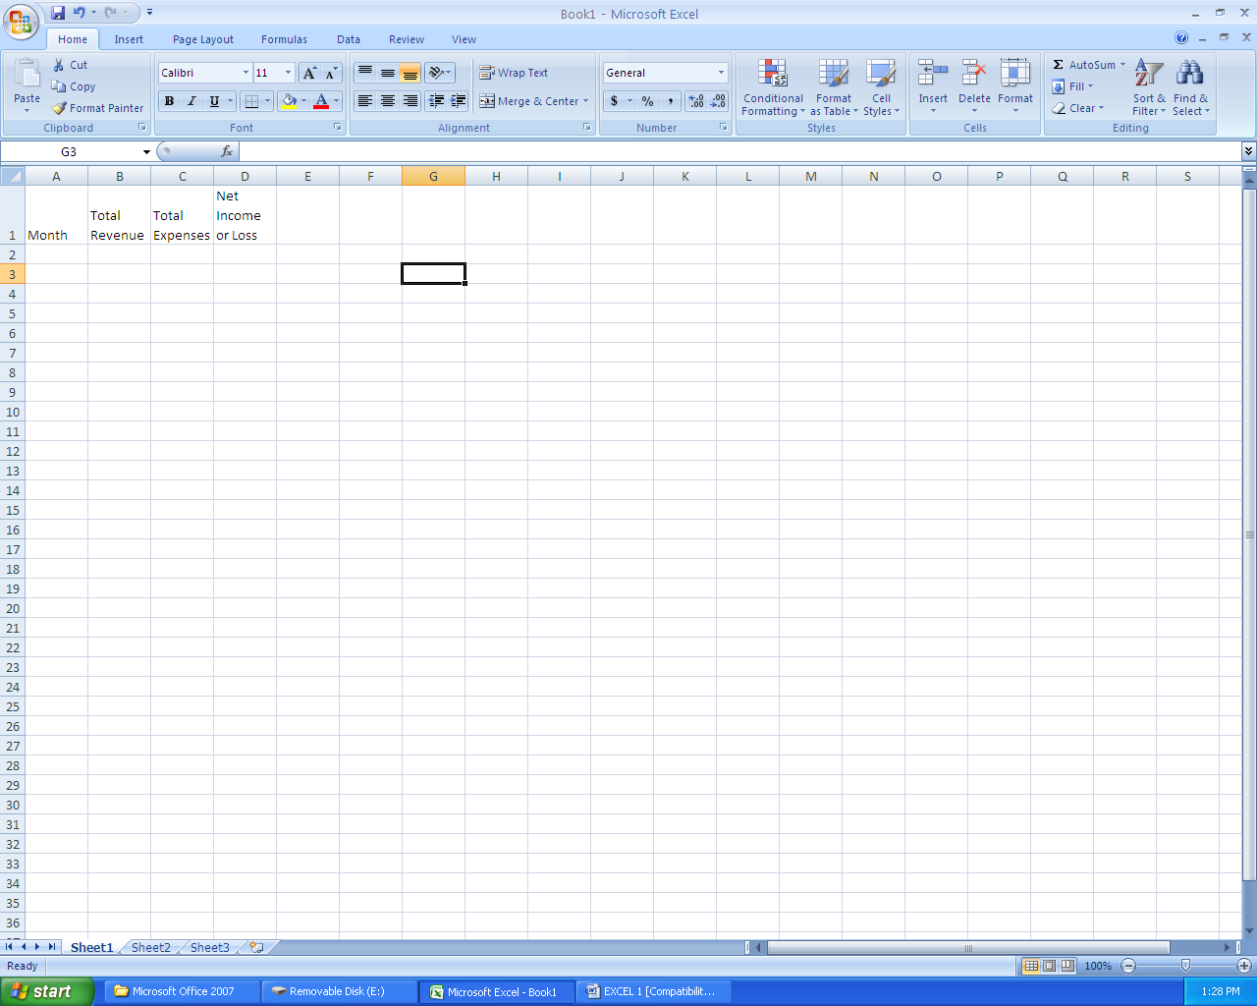Click on the **WRAP TEXT** command

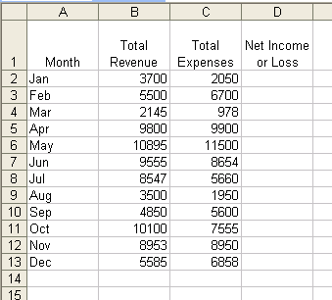**Key the Spreadsheet**

* Key the following company spreadsheet as shown: Longer headings will automatically increase the size of the cell!

**Keying a Formula**

**Don’t forget the = sign!**

* Click on cell **D2** and type this formula: **=B2-C2** and **ENTER**
* Select **D2 through D13**
* 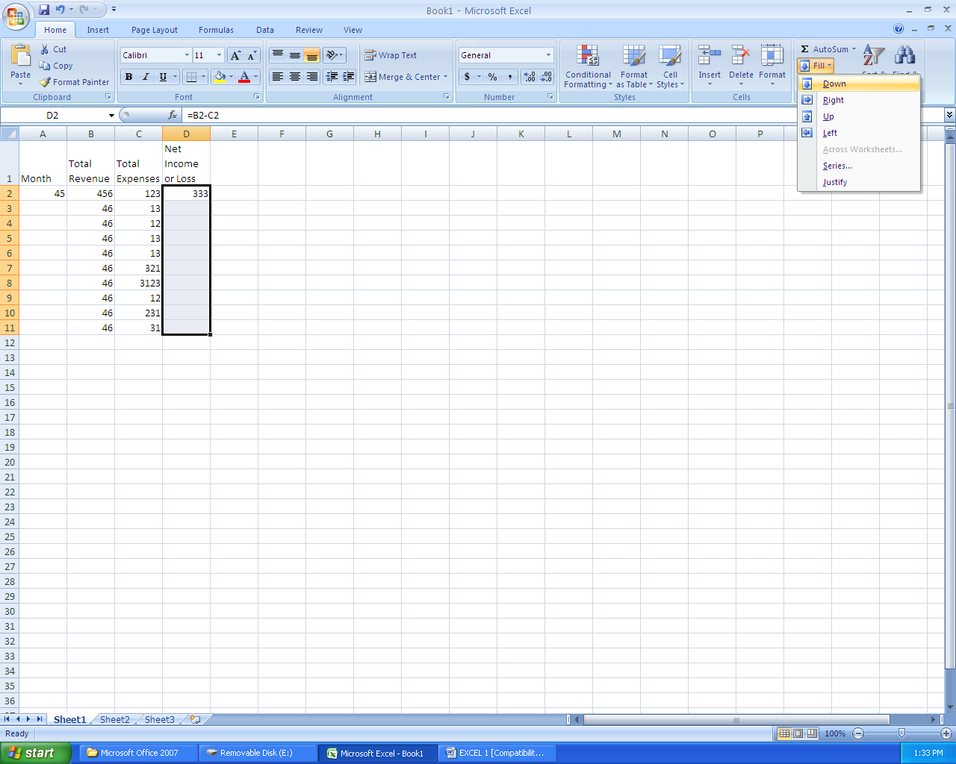 On the **HOME** tab, click **FILL** and **DOWN**

**Finishing Up**

* Select **A1 through D13**
* Click on **HOME** tab
* Select some cells and add some color by clicking on **PAINTBUCKET**

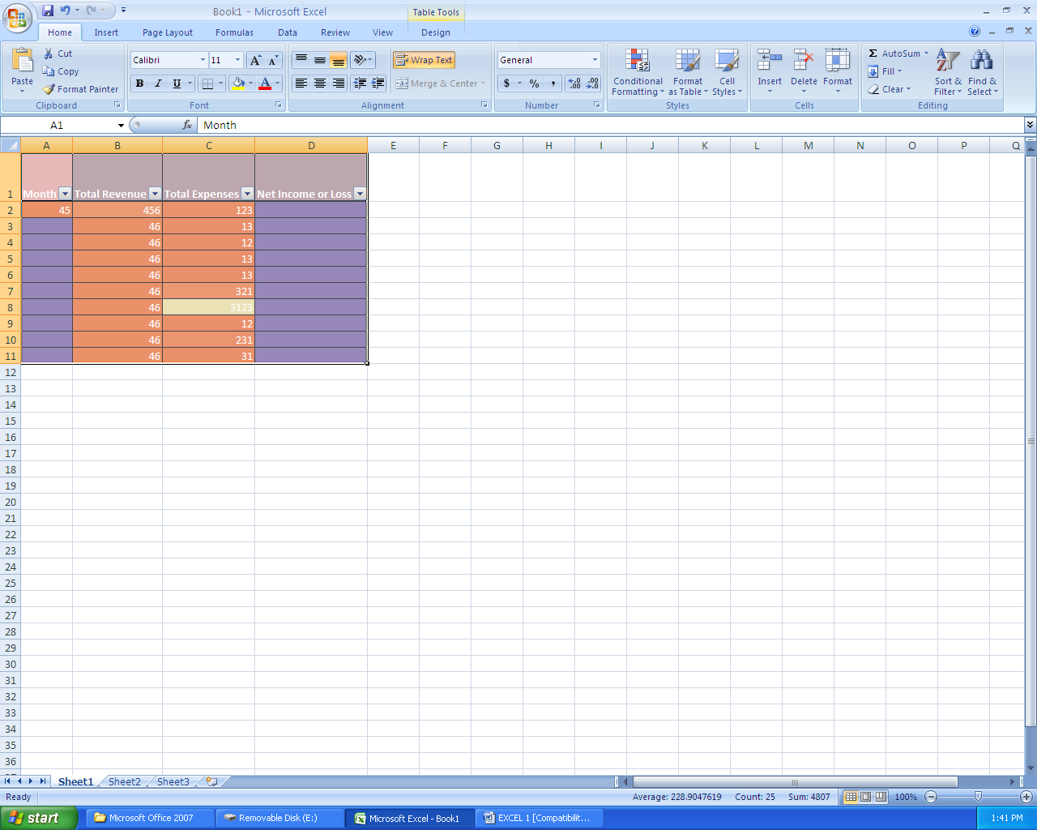

* Click on **PAGE LAYOUT**  tab and click on **SCALE—change to 130%**

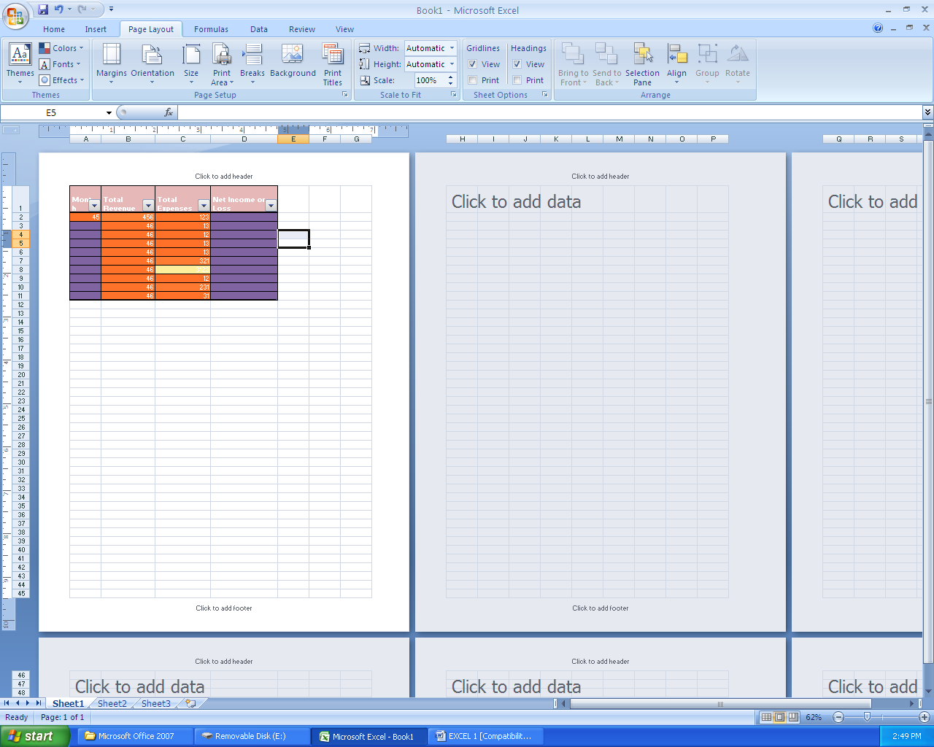

* Click on the **MARGIN** icon and click **CUSTOM MARGINS**

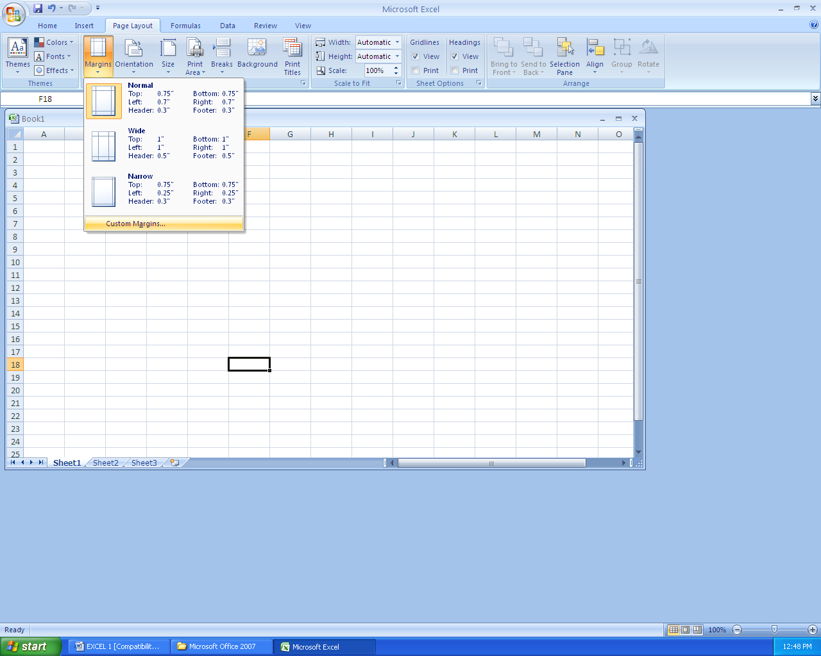

* Click the boxes (to show a checkmark) for **HORIZONTAL** and **VERTICAL** centering…**Don’t click OK yet!**

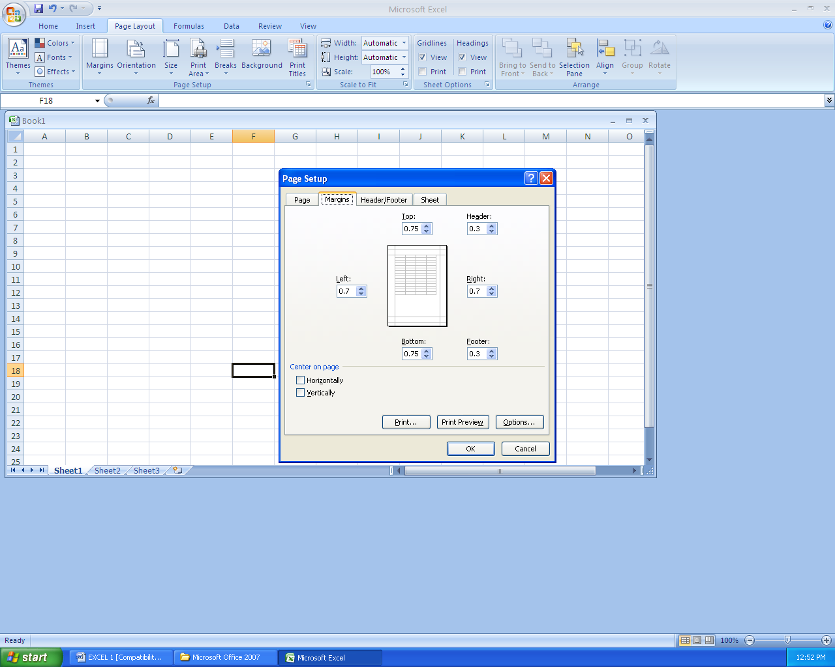

* **DON’T** click **OK**
* Instead, click on the **HEADER/FOOTER** tab and **CUSTOM HEADER**

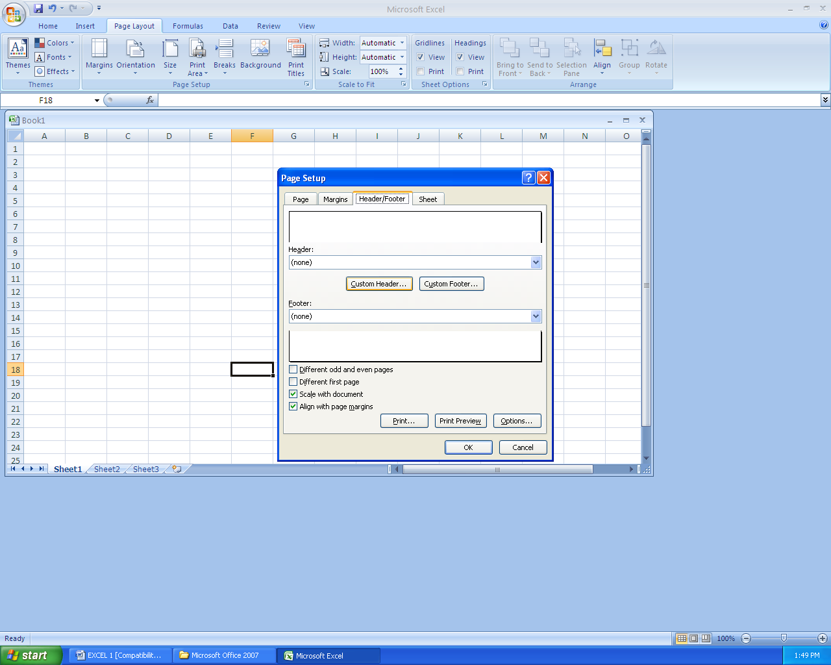

* Type your **NAME** in the left box, the **DATE** in the center box, your **PERIOD #** in the right box

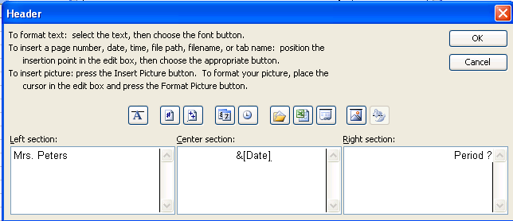

* Click **OK**
* Go to **OFFICE BUTTON** and **SAVE**-- call it **EXCEL 1**
* Go to **OFFICE BUTTON, PRINT** and **PRINT PREVIEW**
* If it looks good and you are ready to turn it in, **PRINT** the document!

**GOOD JOB!!!**