Name: _______________________________
Peripherals Identification
Directions: Below is a list of computer hardware. Classify as either and Input Device, Output Device or Both. Use all words only ONCE. But remember not all blanks in the table below will be filled. When finished save to your desktop and submit via Weebly Assignment form.
Keyboard, Speakers, Mouse, Scanner, Microphone, Graphics Tablet, LaserJet Printer, Joystick, Web Cam, Biometric Devices, Monitor, Plotter, Inkjet Printer, Trackball, Touchpad, Digital Camera, Touch Screen, Projector (Hint: Only one is both an input and output device)

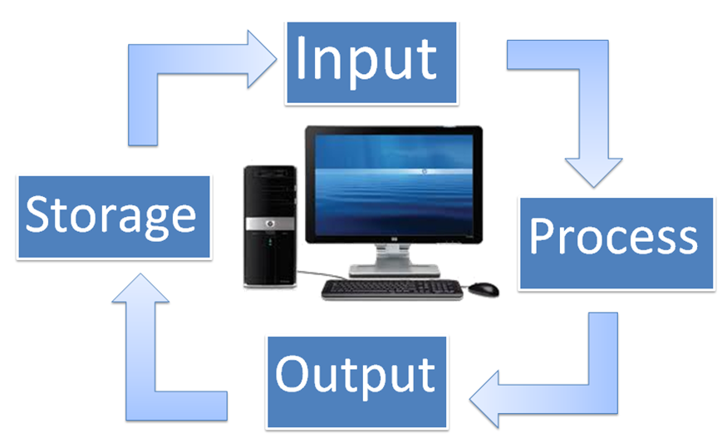

INPUT  DEVICE | OUTPUT  DEVICE | BOTH INPUT AND OUTPUT DEVICE

