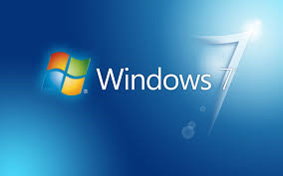
FILE MANAGEMENT & SHORTCUTS ACTIVITY
Digital Literacy

Part A - File Management: Using “Windows Explorer” and “Computer” from your desktop and MS Word, complete the following steps.

1. Create a folder and name it Digital Literacy

2. Open your newly created Digital Literacy folder and create the following subfolders:
Word Processing Spreadsheets
Presentations Digital Citizenship
Information Literacy Research BIG6
Internet (On-Lines Resources) Typing Warm-ups and Drills
Multimedia Online Projects

3. Delete any files you no longer need from previous classes. Move any files that are not in the correct folder to that folder using Windows Explorer and the drag and drop or the cut and paste method. All files should be in a folder.

Part B - Creating Shortcuts: Follow the directions below to create two shortcuts on your desktop. (Hint: These may disappear after you log off, but you can easily recreate them as needed.
2. Create a shortcut to reach your teacher’s web page quickly.
- Go to his/her website and copy the address.
- Follow the instructions below for creating a shortcut.
- Title it Digital Literacy Class
- Hit “Finish” and try out your new shortcut.
- You can change the icon by right clicking on the shortcut and choosing “Properties” and then “Change Icon”. Select one of your choice and hit OK.

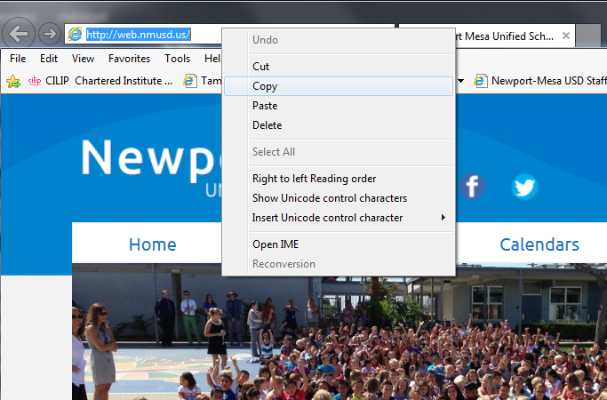

Go to desktop and right click your mouse, select New, then Shortcut.

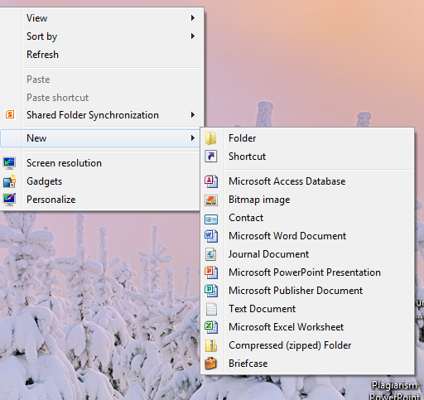

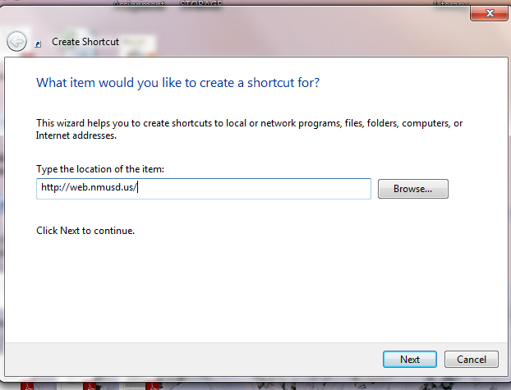

Click Next

And type the title of the folder. Title it “Digital Literacy”. See below.

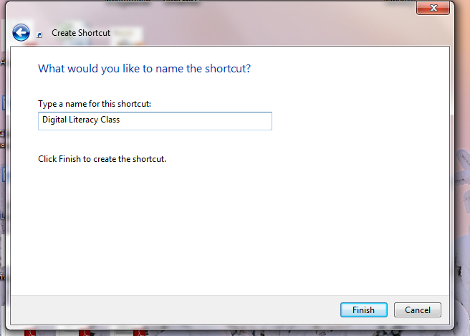

Now click Finish.

