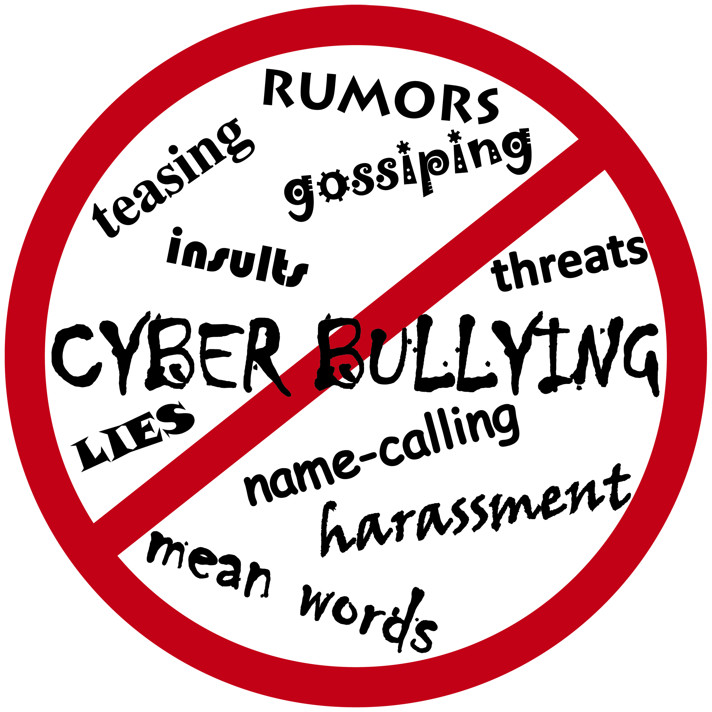
Name: ______________________ Period: ________________
Cyberbullying

Reading Guide

A. News Anchor Story
1. | How was the anchor bullied?
2. | What was her response to the bullying?
3. | What was her main concern for young people?

B. Cyberbullying, technologies and types
1. | What is cyberbullying?
2. | List 5 technologies that are used by cyberbullies:
a.
b.
c.
d.
e.
3. | List 7 types of cyberbullying:
a.
b.
c.
d.
e.
f.
g.

C. Cyberbullying facts, terminology and consequences
1. | Visit the DoSomething.org website. Write down 6 facts about cyberbullying:
a.
b.
c.
d.
e.
f.

2. Read through the Glossary of Cyberbullying terms. In your own words, describe each term:
a. | Flaming
b. | Harassment
c. | Cyberstalking
d. | Denigration
e. | Exclusion
f. | Trolling
g. | Impersonation
h. | Outing & Trickery

D. Cyberbullying Videos
1. | Watch the “Broken Friendship” video—describe what happened and how you feel about it.
2. | Watch the “You Can’t Take it Back” video—describe what happened and how you feel about it.

E. Cyberbullying Quiz
There are 19 questions on the quiz—write your scores here and then add them up:
 | Total score |  | How do you rank?

F. Consequences of Cyberbullying
List 8 things from the tips you can do if you are ever cyberbullied:
Tip 1
Tip 2
Tip 3
Tip 4
Tip 5
Tip 6
Tip 7
Tip 8

What do you think about cyber bullying? Write 3 paragraphs giving your viewpoint.

