How to Make a Timeline in Word
Although Microsoft Word is traditionally used to develop and edit copy, you can still create a visual timeline using SmartArt graphics. You can choose from dozens of timeline layouts and customize the colors to fit your project.
Before you start, we recommend changing the orientation of your Word document from portrait to landscape (go to the Page Layout tab and click Orientation).
Note: We are using Windows running Word 2013 in this example.

Select a Timeline Style
- Open a blank document in Microsoft Word.
- In the Insert tab, click SmartArt.​

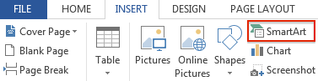
- You’ll see a pop-up box with different kinds of SmartArt graphics, ranging from lists to processes to pictures. You can choose any layout you like, but for this example, we’ll choose the basic timeline layout (the arrow with the dots in the middle).

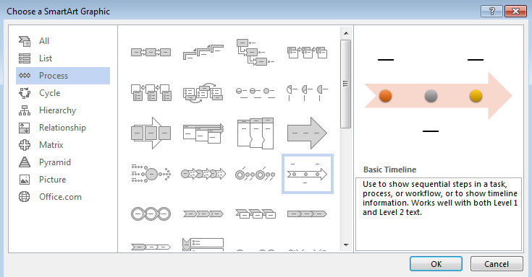

Add Project Information to the Timeline in Word

- To add an entry to the timeline, you can either double-click on the [Text] blurbs in the Word document or type directly in the floating box.

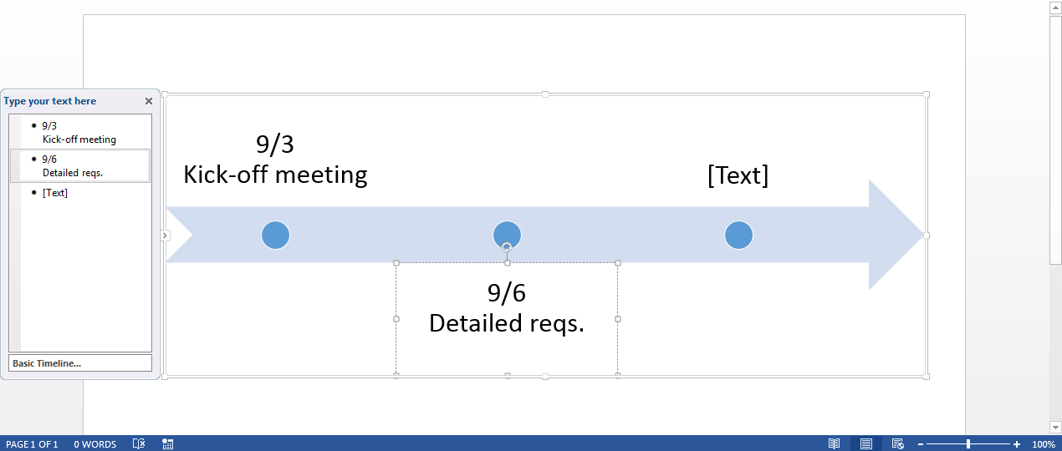
- The basic timeline starts off with three timeline entries, but you can add additional events on the timeline by hitting the Enter key after a bullet point in the floating box.

- If you want to add two events on the same date, first type in the date in the floating box. Then, hit Enter andTab to nest multiple tasks under the same date.
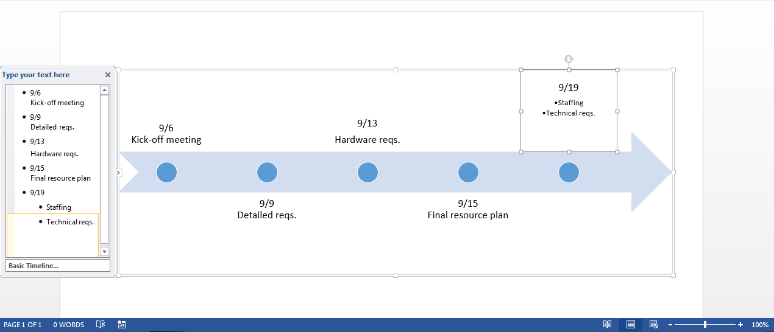
- To delete an entry in your timeline, simply click on the text in the floating box and hit Delete. The timeline will automatically re-adjust.
- To move tasks on the timeline, click on the task in the Word document and click the text box around the words. Drag the text box to the new location.

How to Customize Your Timeline in Word

Once you’ve added your project information and dates, it’s easy to modify the timeline. You can add a title, switch to a different timeline layout, and customize the color palette.

Add a Title

- Double-click on the header area of the Word document (the very top of the document).
- You’ll see a line appear with a little grey box that says Header. You’ll also see your cursor appear in the header area. Start typing your timeline’s title here.

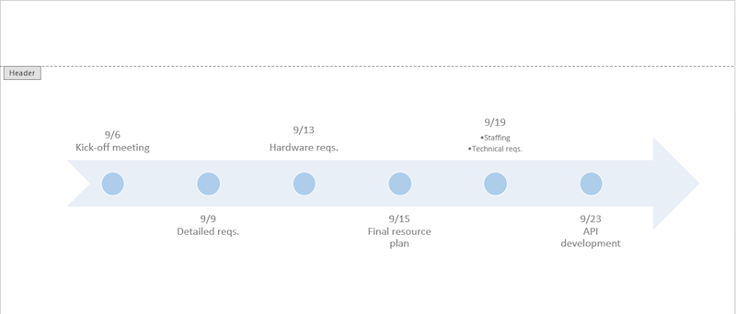
- In the Home tab, in the Fonts group, you can change the font size and color. And in the Paragraph group, you can change the alignment of the text.

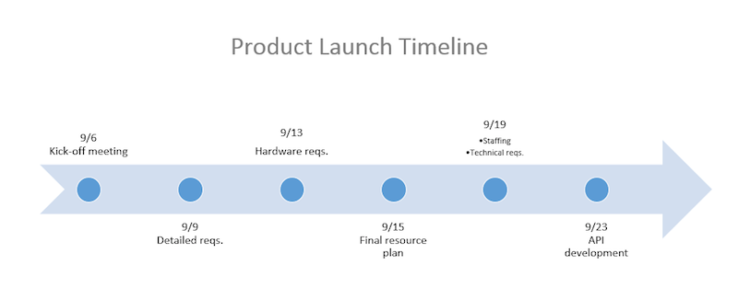

Choose a Different Timeline Layout

- Double-click on the light blue part of the arrow.
- In the Design tab, in the Layouts group, click the bottom arrow on the right side. Here, you can access all the different SmartArt graphic options. Click on the timeline layout you’d like to use.

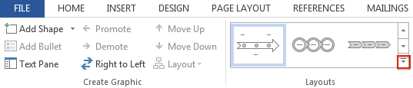

Change the Timeline Color

- To change the background color of the timeline, click the image and in the Format tab, click Shape Fill. Select the new background color you’d like.
- To change the color of the circles, click on a circle, hold down Shift and click the other circles. Select Shape Fill again to pick the color you’d like.
- To change the font and font size of the tasks on the timeline, click on the text in the Word document and in the Home tab, in the Font group, adjust the size, type, and color.

