Name: Period #:

Unit 1—Test Review Assignment
Directions: Identify each peripheral device in the picture below and then click the down arrow on ‘Type of Device’ and select if they are an input device, output device, or both.
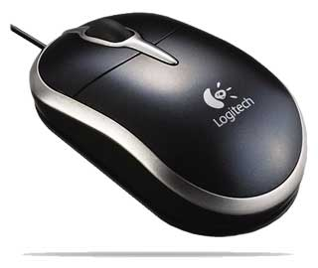  EXAMPLE:  Identify: Mouse  Type of Device: Input Device | 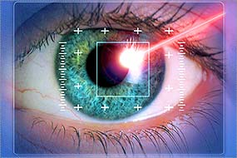  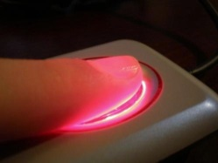  Identify:  Type of Device: Choose an item. | 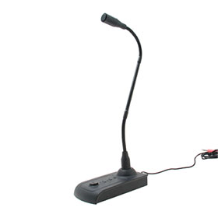  Identify:  Type of Device: Choose an item.
Identify:  Type of Device: Choose an item. | 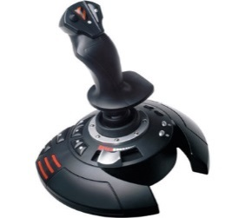  Identify:  Type of Device: Choose an item. | 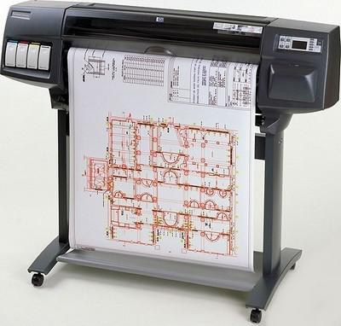  Identify:  Type of Device: Choose an item.
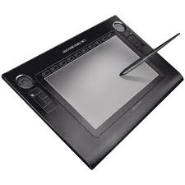  Identify:  Type of Device: Choose an item. | 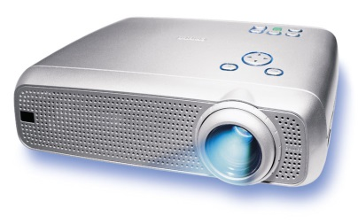  Identify:  Type of Device: Choose an item. | 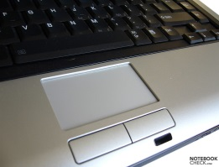  Identify:  Type of Device: Choose an item.
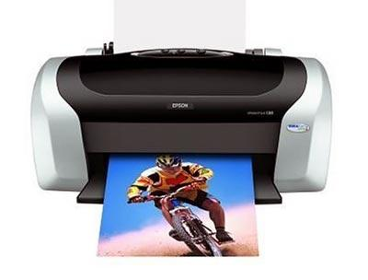  Identify:  Type of Device: Choose an item. | 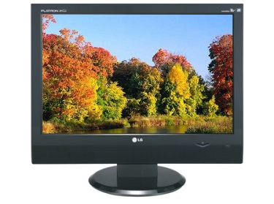  Identify:  Type of Device: Choose an item. | 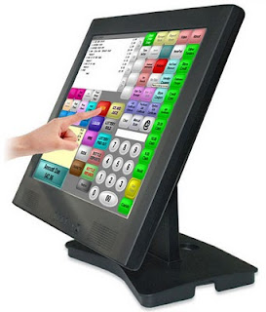  Identify:  Type of Device: Choose an item.
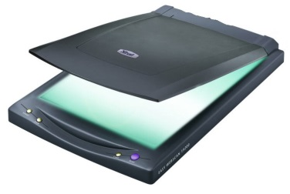  Identify:  Type of Device: Choose an item. | 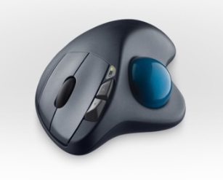  Identify:  Type of Device: Choose an item. | 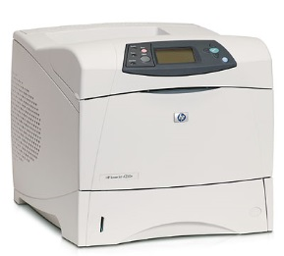  Identify:  Type of Device: Choose an item.
Matching: Match the vocabulary words on the left with the definitions on the right. Write the letter of the vocabulary word next to the definition on the left.
 | The sequence of events that occur between the time you turn the computer on and when it becomes available for use |  | - Hardware  - Input  - Software  - Peripheral Devices  - Multitasking  - Storage  - Graphical User Interface  - Applications  - Output  - Operating System  - WYSIWYG  - Boot Process  - Processing  - Icon  - Menu  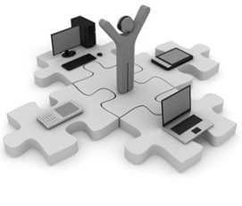
 | The physical, touchable parts of the computer
 | Manipulating Data (bold a word, enter a formula, etc.)
 | Any hardware device connected to the computer that expands the computer’s input, output and storage capabilities
 | The place where data is held when it is not needed for processing
This allows you to use a mouse to click on icons,
buttons and menus
 | Used in contrast to hardware; refers to everything in a computer that is not hardware
 | The master controller on the computer; manages the computer’s memory, processing, software and hardware
 | The results of processed data
 | The ability to have more than one application open at the same time at a time
 | A collection of raw data that is put into the computer
Software designed to help the user perform specific
tasks
 | What you see on the screen is what you get in a printout
 | An image or graphic that represents an executable file
 | A dropdown list or table of executable options

- List the 3 most common operating systems for desktop computers.

- Which operating system has the largest selection of software available?
- Which operating system can be installed, used and customized FREE of charge?
- Which operating system is very stable? (When an application crashes in this operating system, the entire system does not crash).
- List the 3 most common operating systems for mobile devices.

